

Documentation of Microsoft word
1. Introduction
Microsoft Word is a word processing software used to create, edit, format, and print documents. It is commonly used for writing letters, assignments, reports, and projects. In this documentation, we explain which task is performed using which option in Microsoft Word.
2. Creating a New Document
Operation Performed: Create a new blank document
Option Used:
File → New → Blank Document
Explanation:
To start working in MS Word, we first create a new document. This gives us a blank page where we can write our content.
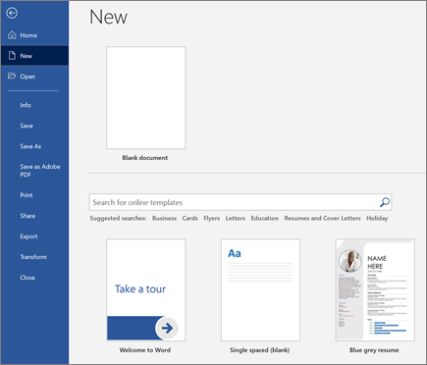
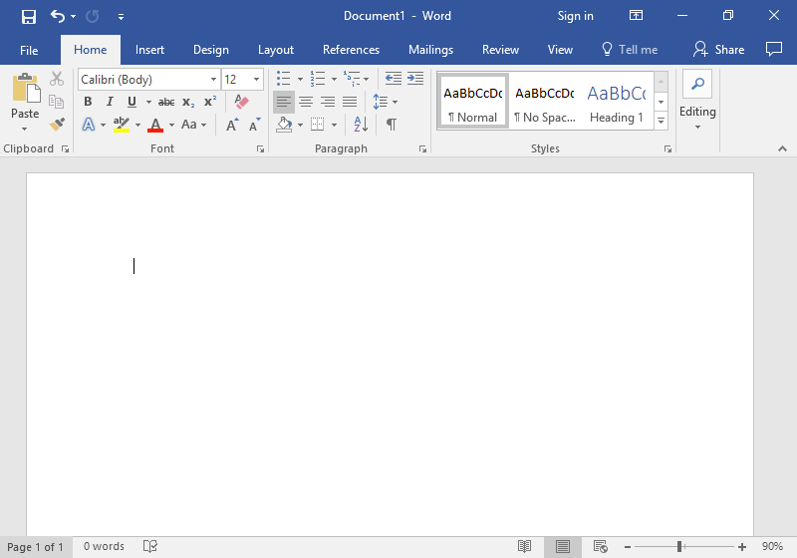
3. Saving the Document
Operation Performed: Save the document
Option Used:
File → Save As → Choose Location → File Name → Save
Explanation:
After writing content, we save the file so our work is not lost. We choose the location and give a file name.
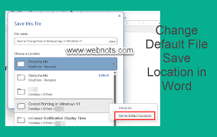
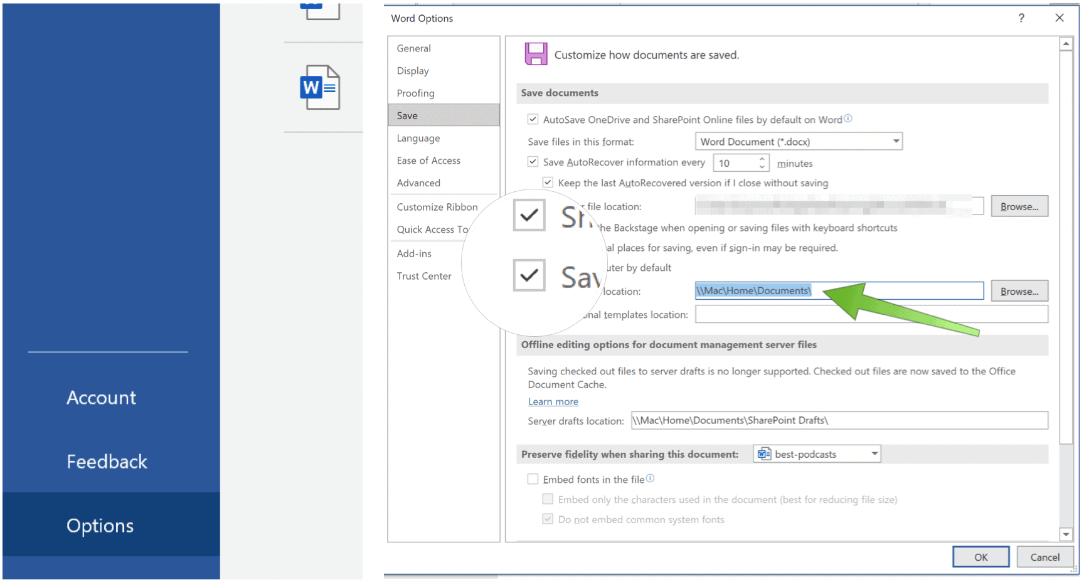
4. Formatting Text (Bold, Italic, Underline)
Operation Performed: Change text style
Option Used:
Home Tab → Font Group → Bold (B), Italic (I), Underline (U)
Explanation:
These options are used to make text dark (bold), slanted (italic), or underlined.
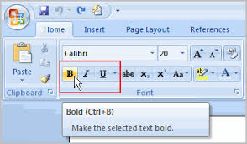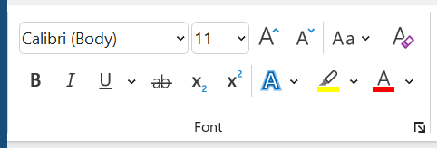
5. Replacing Text (Find and Replace)
Operation Performed: Replace words in the document
Option Used:
Home Tab → Editing Group → Replace
Explanation:
The Replace feature is used to quickly change a word or sentence throughout the entire document.
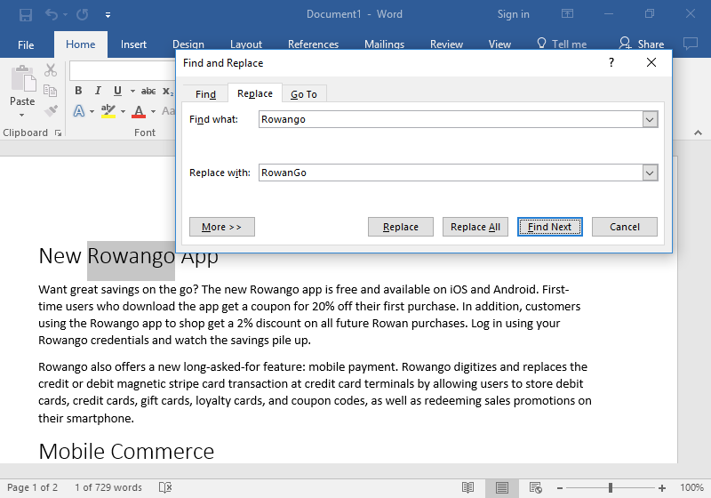
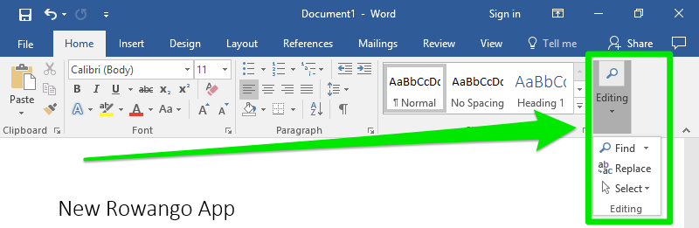

6. Changing Font Size and Style
Operation Performed: Change font size and font type
Option Used: Home Tab → Font Group → Font Style & Font Size Box
Explanation:
We use this option to change the appearance of text such as Times New Roman, Arial, and the size like 12, 14, 16, etc.
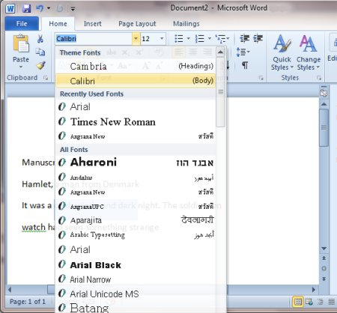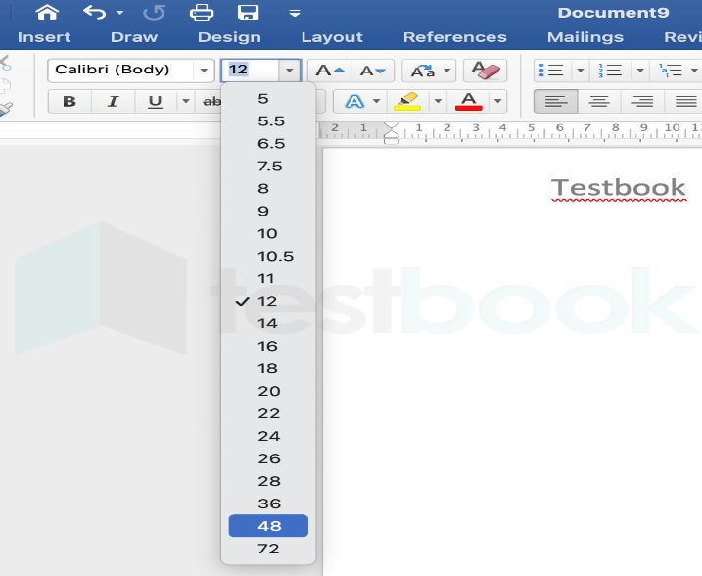
7. Adding a Text Box
Operation Performed: Adding a text box
Option Used:
Insert Tab → Text Box → Simple Text Box
Explanation:
A text box allows us to write text anywhere on the page separately from the main text. It is mostly used for writing short notes, headings, or important information on the side of the page. 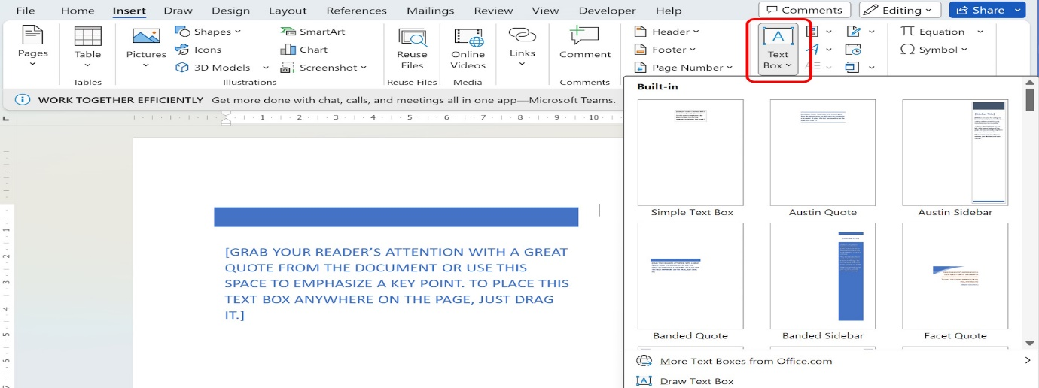
8. Adding a Table of Contents
Operation Performed: Create a table of contents
Option Used:
References Tab → Table of Contents → Select Style
Explanation:
A table of contents automatically shows headings with their page numbers. It helps readers quickly find topics in long documents.
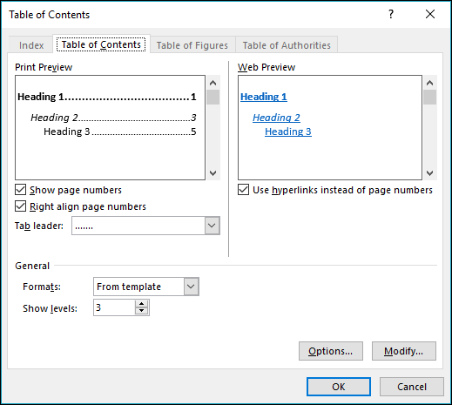
9. Adding a Picture
Operation Performed: Insert an image
Option Used:
Insert Tab → Pictures → This Device → Select Image → InsertExplanation:
This option is used to add pictures into the document for better presentation. 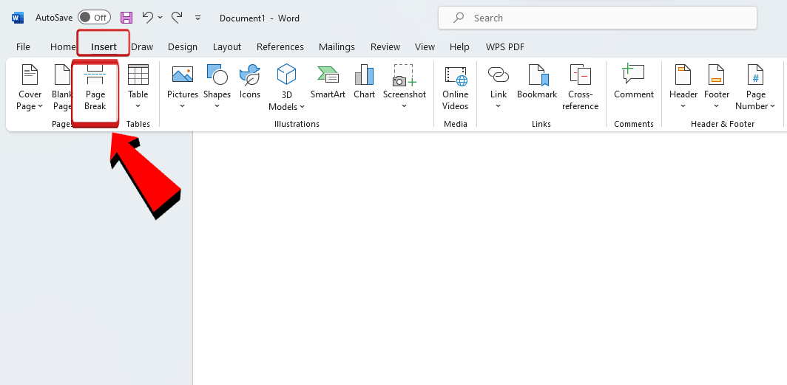
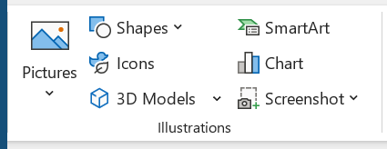
10. Formatting a Picture
Operation Performed: Editing or formatting a picture
Option Used:
Click on the Picture → Picture Format Tab → Corrections / Color / Wrap Text
Explanation:
Picture formatting is used to change how a picture looks in the document. We can change its size, move it, adjust brightness, change colors, and fix how text appears around the picture.
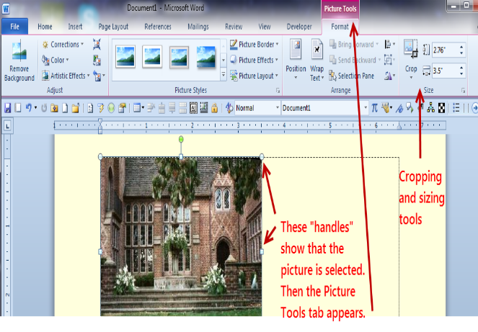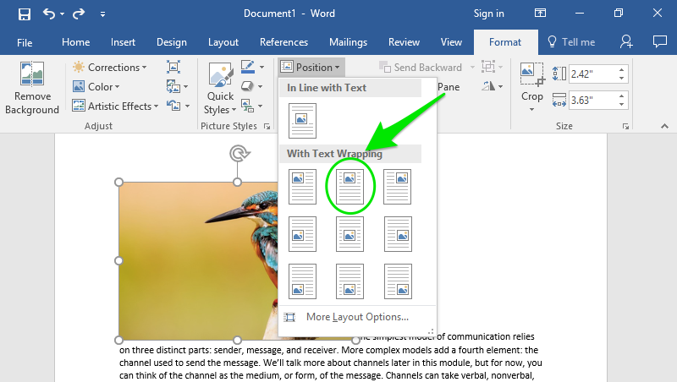
11. Adding a Watermark
Operation Performed: Add a watermark
Option Used:
Design Tab → Watermark → Select Watermark
Explanation:
A watermark is a light background text or image (like “Draft” or “Confidential”) shown behind the main text.
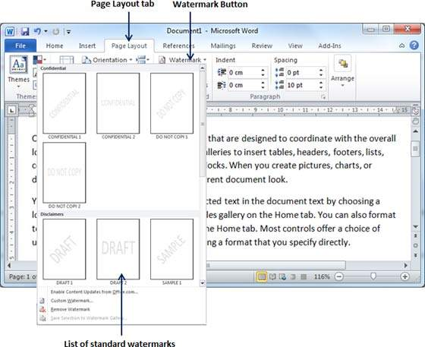

12. Adding a Table
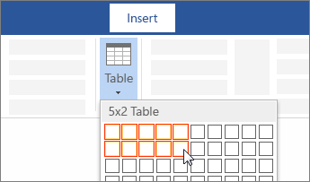
Operation Performed: Insert a table
Option Used:
Insert Tab → Table → Select Rows and Columns
Explanation:
Tables are used to organize data in rows and columns.
13. Applying Shading
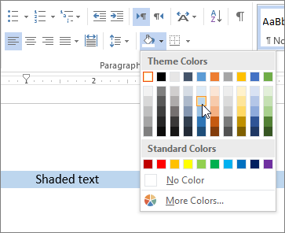
Operation Performed: Apply shading to text or
paragraph
Option Used:
Home Tab → Paragraph Group → Shading
Explanation:
Shading is used to apply background color to text
or a paragraph to highlight important content.
14. Changing Page Orientation
Operation Performed: Change page layout
Option Used:
Layout Tab → Orientation → Portrait / Landscape
Explanation:
This option is used to change the page direction.
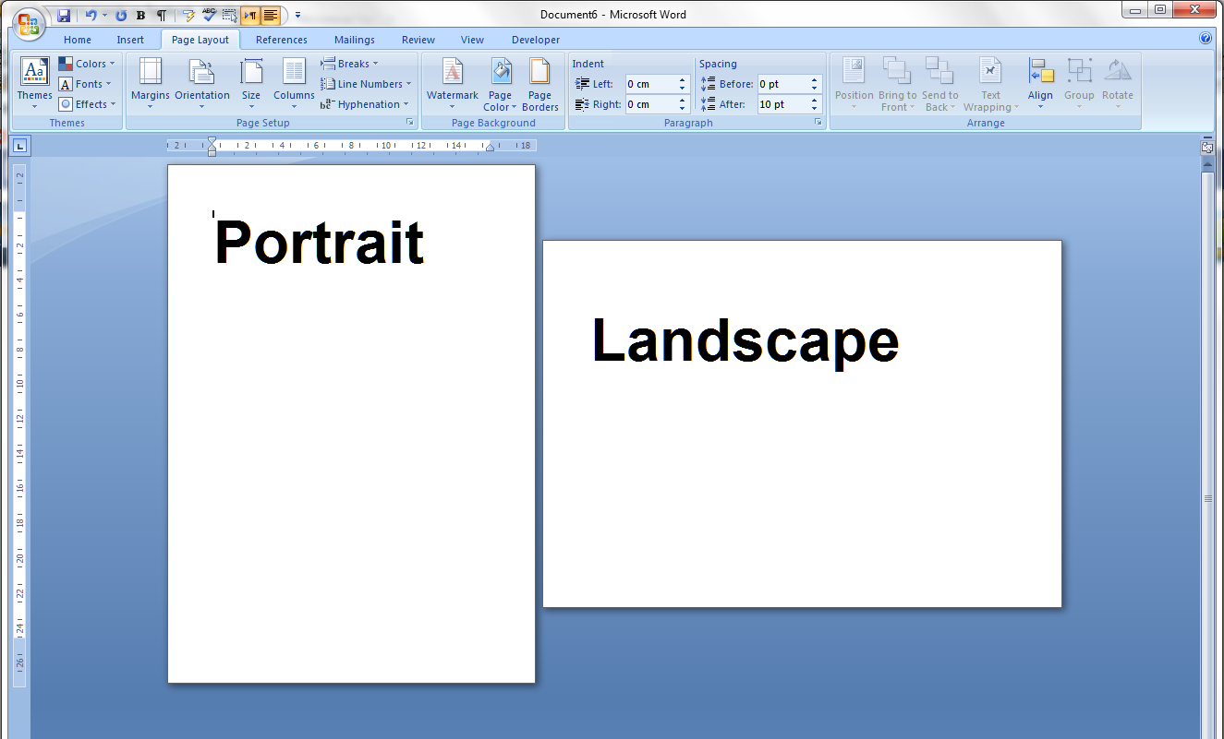
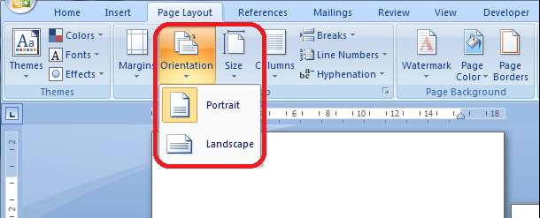

15. Setting Page Margins
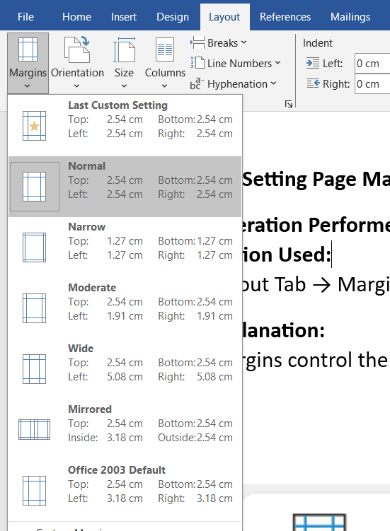
Operation Performed: Set page margins
Option Used:
Layout Tab → Margins → Choose Margin Size
Explanation:
Margins control the empty space around the page.
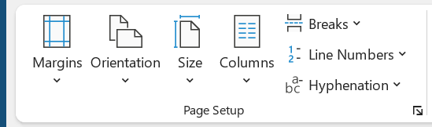
16. Adding Header and Footer
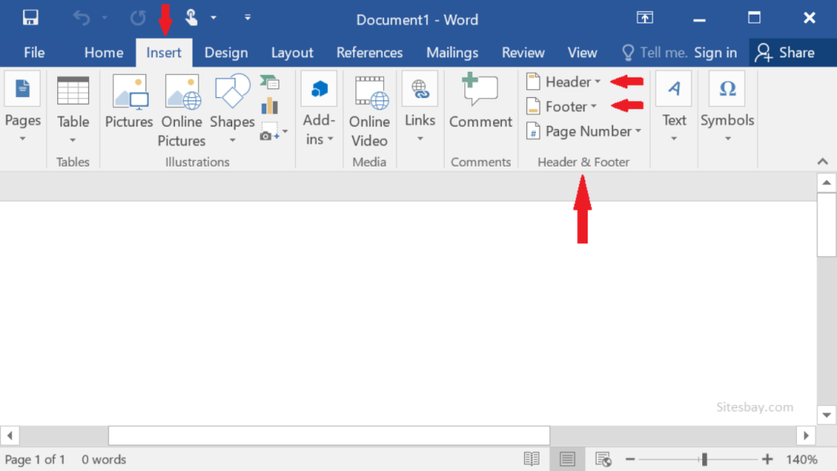
Operation Performed: Add header and footer
Option Used:
Insert Tab → Header / Footer
Explanation:
Headers and footers are used to show titles, page
numbers, and dates.
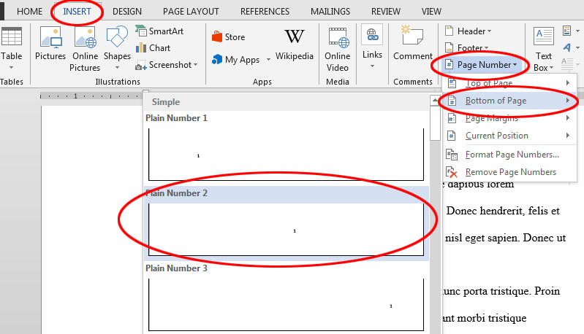
17. Adding Page Numbers

Operation Performed: Add page numbers
Option Used:
Insert Tab → Page Number → Select Position
Explanation:
Page numbers help to organize long documents.
18. Spell Check and Grammar Check
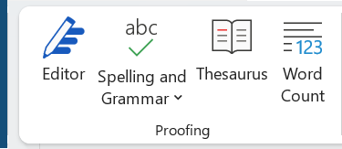

Operation Performed: Check spelling and grammar
Option Used:
Review Tab → Spelling & Grammar

Explanation:
This tool helps to find and correct spelling and grammar mistakes.
19. Printing the Document
Operation Performed: Print the document
Option Used:
File → Print → Select Printer → Print
Explanation:
This option is used to take a hard copy of the document.
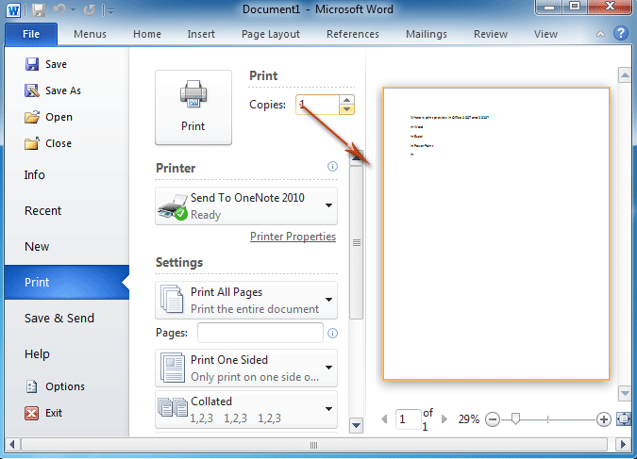
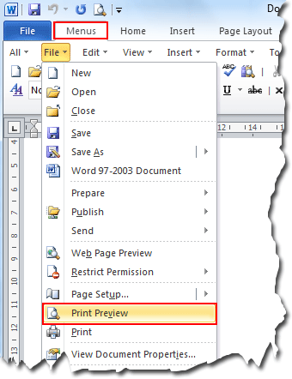
20. Conclusion
Microsoft Word is an easy and powerful software for creating documents. In this documentation, we explained each operation and the exact menu/option used, such as inserting pictures from the Insert menu, formatting text using the Home tab, and printing through the File menu. These tools help users prepare professional documents easily.

